# Acceptance Criteria Testing

## Story ID 15

User Story: As the driver I want to see what packages have higher or lower priority so I know where I should be delivering first.

* I can see a digital list of my current deliveries for the day.
* I can sort this list by priority.
* The list will be updated when pickups are needed.

I can see a digital list of my current deliveries for the day.

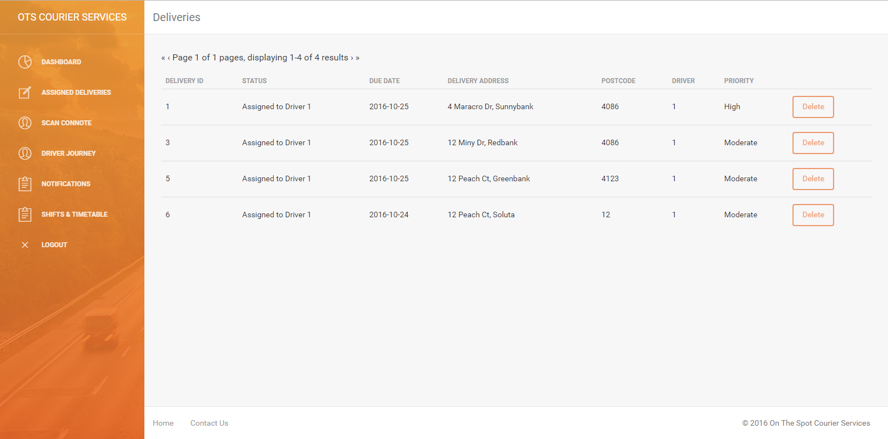

**NOT IMPLEMENTED -> Sort by priority.**

Due to time constraints sorting by priority was not included. That makes this story, in its current state, very similar to story 7. However it was still included to make clear the original intentions of the user story and the final product.

Jeff Jefferson is gone

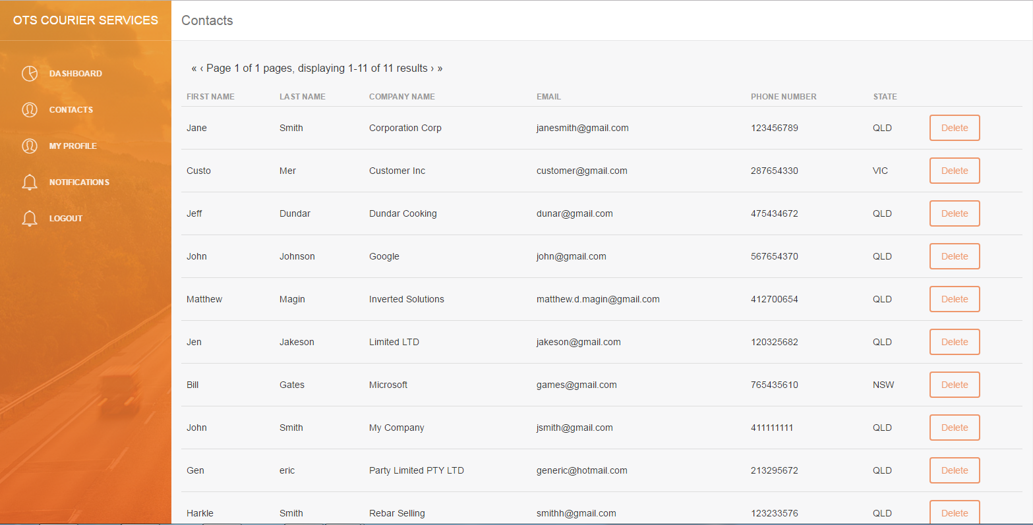

NOT IMPLEMENTED → ADD CONTACT

During development, it was found since the current iteration of the contacts page draws from the customers table and adding a contact would effectively create an account for them (complete with a password) either this function needs to be available to the customers themselves or be retooled to use a different table.